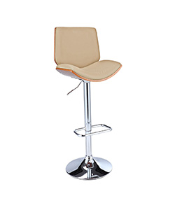

Durian office chair

$26.14

Availability: In stock

### Description

Made of high quality PVC leather for a durable and soft surface. Made of steel frame for a durable long life use. High resilient Polyurethane foam for great seating comfort. Adjustable height with Gas lift Solid units, classic lines and the impeccable elegance of the finishes and covers. The light and fresh design, tapered legs, and oatmeal tweed upholstery of this seating collection